Graph 1
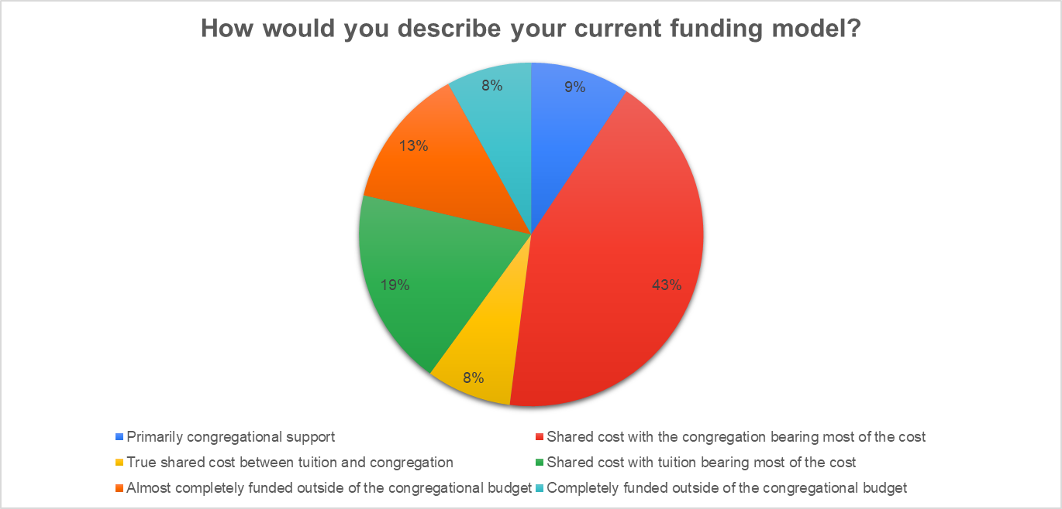
- What percent of WELS LES who took the survey have 50% or more of their budget funded by tuition/vouchers?

- What factors impact where your school is at on this chart?

- What conclusions can be drawn from this chart?

Graph 2
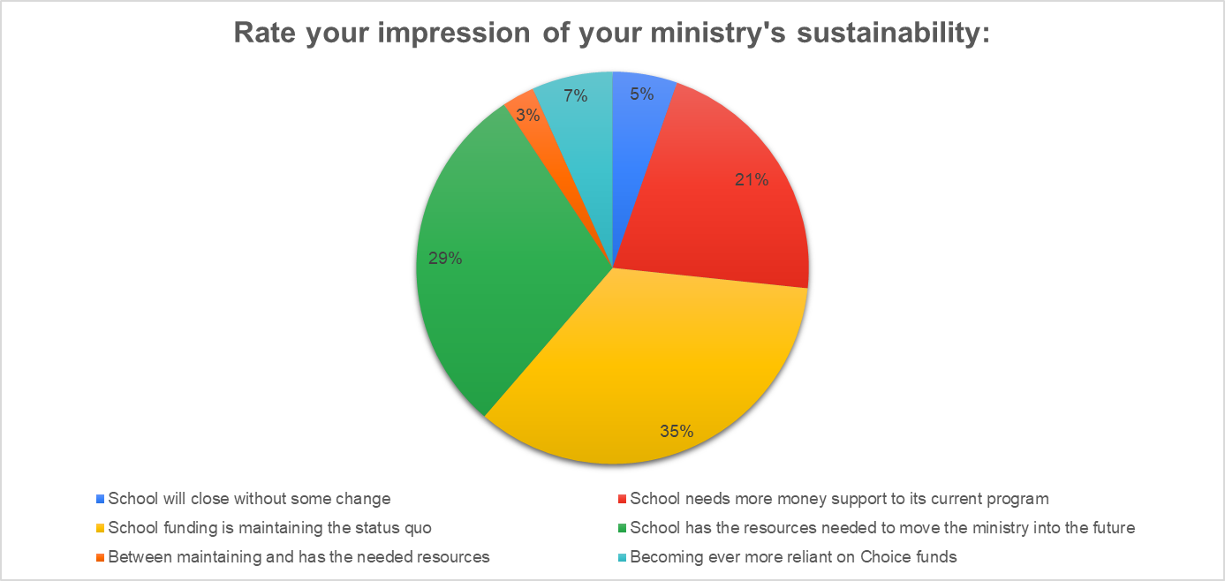
- Would “maintaining status quo” be considered sustainable or unsustainable? Why?

- What percent of WELS LES who took this survey are considered sustainable?

- What conclusions can be drawn from this chart?

Graph 3
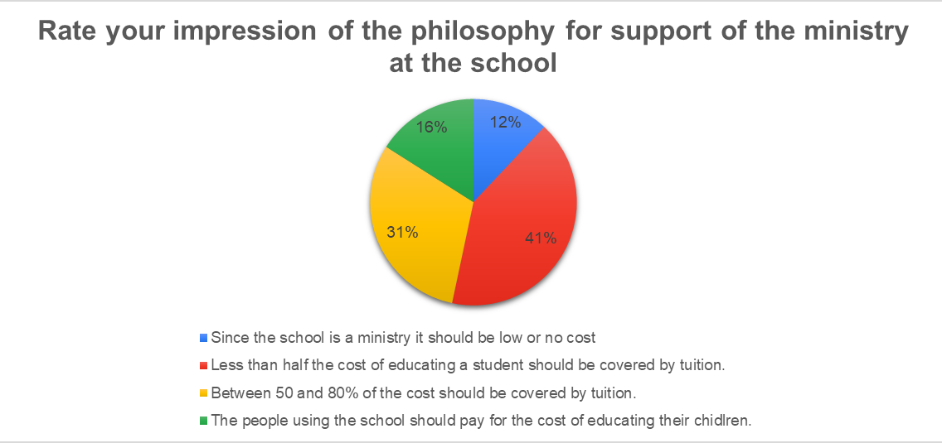
- How might you develop congregational consensus behind one of these statements?

- What might make people move from low/no cost to a higher percentage of the cost of education?

- What conclusions can be drawn from this chart?

Chart 4
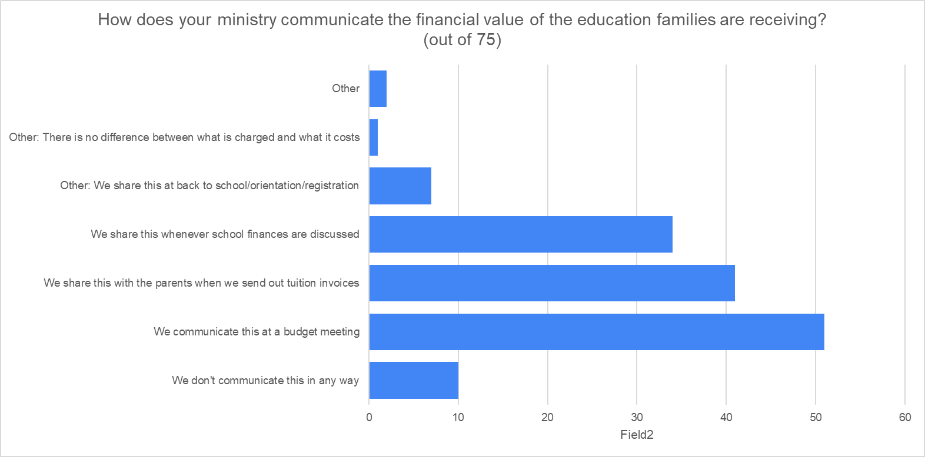
- Which options are good practice, but reach few people?

- How does your congregation communicate the financial value of the education (Cost of education-Tuition=Financial Value)

- What conclusions can be drawn from this chart?
